- INTRODUCTION:

1.1 Overview:
Foreign Direct Investment (FDI) has been one of the defining features of the World economy over the past year. Foreign direct investment (FDI) in India is a major monetary source for economic development in India. Foreign Direct Investment (FDI) is an investment directly into production and services in a country by a company located in another country, either by buying a company or by expanding business in that country. It is a mode of doing business in a foreign country . It also focuses on the determinants and needs of FDI, year-wise analysis, sectoral analysis and sources of foreign direct investment, and reasons. One of the economic aspects of globalization is the fact that increasing investments in the form of foreign direct investments.This Tableau Project shows that the share of top sector in US $ attracting highest FDI equity inflows in India. In this study used descriptive statistical tools such as percentage analysis, tables, and charts are used for analysis and interpretation of data. The present study has focused on the trends of FDI Flow in India during 2000-01 to 2016-2017. The study also highlights country wise approvals of FDI inflows to India and the FDI inflows in different sector for the period April 2000 to March 2017.The presents statement on RBI's regional offices received FDI equity inflows. Foreign direct investment (FDI) equity inflows into India rose 9% to a record $43.5 billion during fiscal year 2016-17, at a time when global FDI inflows are falling. The services sector continued to attract the highest investment at $8.9 billion, followed by telecommunications which attracted $5.6 billion. FDI equity inflows during the past three financial years (2014-15 to 2016-17) is $109.41 billion. This is an increase of 40% from $81.84 billion in the previous three fiscals (2011-12 to 2013-14). The present research study methodologies are data collections relating FDI and tools used for analysis and interpretation of data. The primary focuses with the data collection and the secondary parts deals statistical tools used for the purpose of analysing and interpretation of data. This study carried out exploratory nature with the help of the secondary data. It contains the necessary data collected government site. The sources include the annual reports and other reports published by the various RBI Annual Reports, Department of Economic Affairs, SEBI, Department of Industrial Policy and Promotions Reports, Ministry of Commerce and Industry, Government of India and Economic survey of India.
A foreign affiliate is an incorporated or unincorporated enterprise in

1.2. Purpose:
FDI is considered as one of the important economic force through which developing countries can carry out economic growth consequently. FDI plays a key role in the globalization process in terms of financing, transferring of skills, knowledge and technology between countries. The policies of the Indian Government seek to encourage investments in domestic infrastructure from both local and foreign private capital. FDI ensures a huge amount of domestic capital, production level, and employment opportunities in the developing countries, which is a major step towards the economic growth of the country. The effects of FDI are by and large transformative. The past three decades have observed significant growth in global diversification by multinational corporations need huge amount of capital investment. FDI is the main source for capital formation in India. Foreign direct investment plays an important role of bridging the gap between the available resources or funds and the required resources or funds India’s abundant and diversified natural resources, its sound economic policy, good market condition and high skilled human resources make it a proper destination for FDI. The Investment of FDI in various states and sector leads to rapid growth of Indian economy. In this backdrop this research significant it analysis an important role of FDI in the long-term development of a country not only as a source of capital but also for enhancing competitiveness of the domestic economy through transfer of technology, strengthening infrastructure, raising productivity and generating new employment opportunities.

2.LITERATURE SURVEY:
- Reetu Sharma and Nikita Khurana (2013) found that, Indian economy is mostly based on agriculture. So, there is a most important scope of agriculture services. Therefore, the foreign direct investment in this sector should be encouraged
- Mahanta Devajit (2012): investigated the impact of FDI on economic growth in India and suggested FDI needed for its sustained economic growth and development through creation of jobs, expansion of existing manufacturing industries, short and long term project in the field of healthcare, education, research and development (R & D) etc.
- Nayak, Ranjan Kumar (2013) has examined the growth patterns and changing nature of Indian inward Foreign Direct Investment, with an emphasis on the post liberalization period, since FDI, along with trade, has been an important mechanism which was brought about a greater integration of Indian economy with world economy.
- Siddharth Alok: Challenges and Future prospects of Foreign Direct Investment In India .

2.1 Existing problem:
Seeking FDI has always been more than just about foreign capital. FDI is important as India would require huge investments in the coming years to overhaul its infrastructure sector to boost growth. Decline in foreign inflows could put pressure on the country's balance of payments and may also impact the value of the rupee. Foreign direct investment is one of the area of growing economic globalization. In India, investment has always been an issue for its development. Those countries which are already developed are now focusing on new markets where there is abundant labours, scope for production, and high profit are achieved. In India, most of the FDI is directed towards infrastructure and energy resources. Most of the approvals were made in the non-manufacturing sector as compared to the manufacturing sector. The service sector in India recorded in its share during the period of 1992-1994, but it slackened off due to shortfall of demand. During the last 5-6 years this growth has again picked up in the nation. Apart from being a demanding driver of economic growth, foreign direct investment (FDI) is a major source of non-debt financial resource for the economic development of India.

2.2 Proposed Solution:
The Government has taken various economic reforms measures to make a path way to open new sector so as to attract foreign direct investment. FDI policy modifications are introduced to bring ease of doing business and gear up the velocity of foreign investment in India. Indian emerging markets and attractive investment opportunities force external investor to invest in Indian economy. Indian government incentives to foreign investors to attract and promote foreign direct investment in order to supplement domestic capital, technology and skills, for accelerated economic growth . Liberalization of policies plays a significant role foreign capital inflows rising steadily for economic development, economic growth in the host economy and across the world. FDI inflows stood at $60 billion in the previous fiscal. Investment(FDI), the Government has set up a investor-friendly policy, wherein except from a little negative rundown, most areas are open for 100% FDI under the Automatic course. Further, the policy on FDI is evaluated on a progressing premise, to guarantee that India stays alluring and speculator agreeable goal. Changes are made in the policy in the wake of having escalated interviews with partners including summit industry chambers, Associations, agents of businesses/gatherings and different associations thinking about their perspectives/remarks. The FDI strategy is relevant over the parts/businesses and similarly applies to the SME segment. Separate information regarding investment made by foreign companies in Small and Medium Enterprises (SMEs) is not maintained. Further, investment by foreign companies who invested in India is maintained remittance wise, which is extremely voluminous. Foreign Investment in various sectors bring international best practices and latest technologies leading to economic growth in the country and providing much needed impetus to manufacturing sector and job creation in India. In line with the policy to provide boost to the manufacturing sector and give impetus to the ‘Make in India’ initiative, the Government has allowed a manufacturer to sell its items through discount or potentially retail, including through web based business under programmed course. To look after the interest of Indian SME sector, certain arrangements have been given to FDI in retail trading sector. For retail trading of single brand items, in respect of proposals involving foreign investment beyond 51%, sourcing of 30% of the estimation of merchandise bought, has been mandated to be done from India, preferably from MSMEs, village and cottage industries, artisans and craftsmen, in all sectors. With a view to deliver profit to farmers, give impetus to food processing industry and create vast employment opportunities, 100% FDI under Government route for trading, including through web based business, has been allowed in regard of sustenance items made as well as delivered in India.
SUGGESTIONS FOR INCREASED FDI IN INDIA:
Followings are the essential suggestions that will help India in increasing FDI:
A. Flexible labour laws needed B. Re look at sector-wise caps
C. Geographical disparities of FDI should be removed
D. Promote Greenfield projects
E. Develop debt market
F. Strengthen research and development in the country

3. THEORITICAL ANALYSIS
During the study period out of 18 financial years, 13 financial year’s shows positive growth and 5 financial years shows that negative growth of FDI equity inflows in India. It also indicates that share of top ten countries contributed 87% FDI inflows and rest reaming 13%. Total top ten sectors Rs. attracted nearly 66% FDI inflows and rest 34% inflows by others. This study results point toward top seven RBI’s Regional Offices attracted 75% FDI inflows and rest 25% inflows attracted by other states. This research study concluded doing business 2016 report indicates that India is rank 100th out of 190 economies on the ease of doing business. This research study suggested that Government of India, State and Union territories governments, RBI, Ministry of finance and DIPP should not only focus in the top ten sector Rs. and countries and also necessary to attract FDI inflows from rest of the sector Rs. and countries by way of providing special incentives for rest of the counties by taking various economic reforms like interest loan subsidies, removal of restrictions, Tax holiday and tax exemptions.

3.1 Block Diagram:
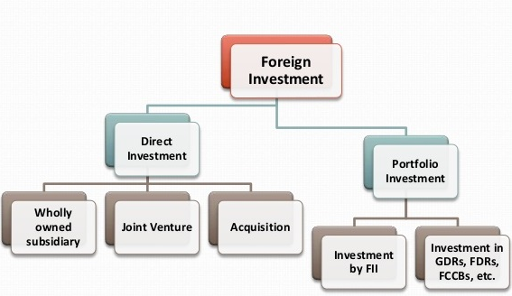

  - Hardware and Software designing:
- Software used: Tableau Application for visualizing data.
- Zoom Meeting for recording a explaining video.

4. EXPERIMENTAL INVESTIGATIONS:
Reserve Bank of India has been maintaining the exchange rate in the country through its exchange control measures. But the constant and continuous supply of foreign exchange is a must for continuing exchange rate stability. With more FDIs coming into the country, this is made possible and today RBI is having a comfortable foreign exchange reserve position of more than 1 billion dollars. The share of top sector. attracting highest FDI equity inflows from April, 2000 till 2016 into India. This result of the study indicates that the highest amount of highest FDI equity inflows attracted by services sector Rs. 18%, followed by Computer Software & Hardware sector Rs. 8% secured as second position. Third place secured by Telecommunications sector Rs. 8% of inflows, followed by Construction Development sector Rs. 6% FDI equity inflows into India. Trading sector Rs. 5% FDI equity inflows, followed by Automobile Industry sector Rs. 5% of FDI equity inflows. In the list shows that the seventh position secured as Drugs & Pharmaceuticals sector Rs. 4% of FDI equity inflows, Chemicals sector Rs. attracted 4% FDI equity inflows, Power contributed 4% of FDI equity inflows and Construction (infrastructure) attracted 3% FDI equity inflows during the study period. Total top 10 sector Rs. attracted nearly 66% and rest of the sector Rs. attracted 34% of total FDI equity inflows into India from April, 2000 to June, 2018

5.FLOWCHART:

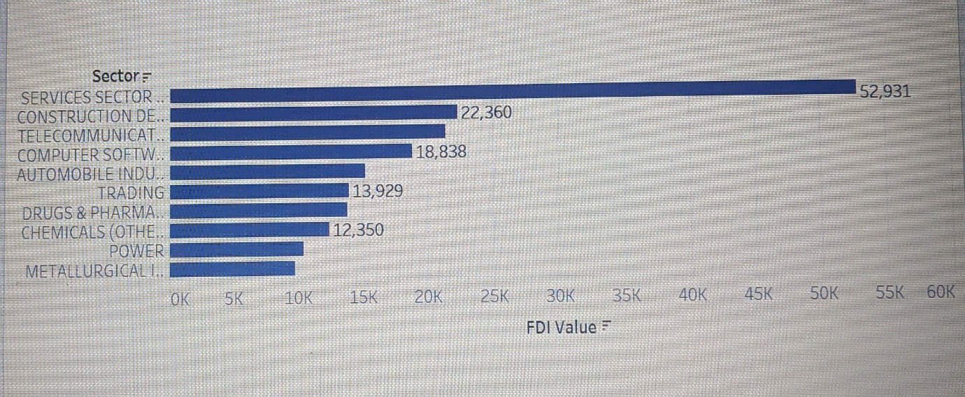

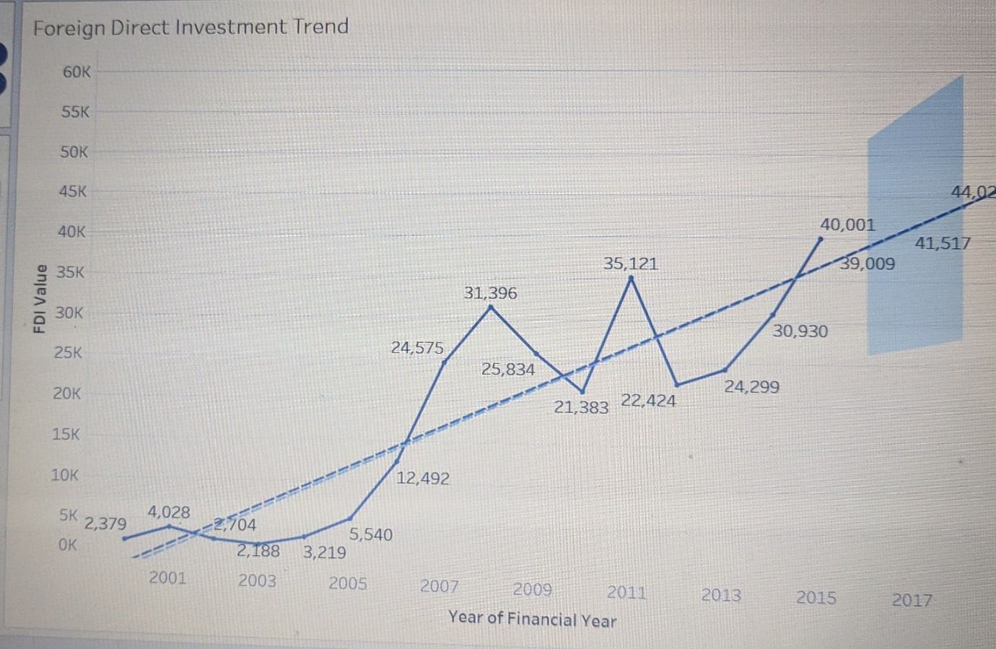

6. RESULT:
The key sectors which attracted the maximum of these inflows include services segment, computer software and hardware, telecommunications, trading, construction development, automobile, chemicals, and pharmaceuticals. FDI in India is an indication of foreign investor's firm belief in India's strong economic fundamentals, stable political outlook and sustained economic growth
This growth is a strong reflection of the market potential of India coupled with the steady state of market reforms that India has undertaken since 2000, including opening up of various sectors of the economy to 100 per cent FDI over the last 5 years while the overall market potential of India will always be high, given the large population, many other factors like ease of doing business, land, labour laws, tax rates, availability of talent, logistics, and political stability also play important role in attracting FDI to any country.
clarity on regulatory and tax issues could help increase FDI and the government should also consider further liberalisation of capital intensive industries like banking and insurance.

SECTORAL COMPOSITION OF FDI :
The sectoral composition of Foreign Direct Investment over the period of April 2000 to March 2019, we can find that the largest recipient of such investment is service sector ( Financial, Banking, Insurance, Non Financial/ Business, Outsourcing, Research and Development, Courier, Technology Testing and Analysis, Other). The share of this sector in cumulative FDI flows is 17.65% of the total foreign direct investment. The foreign investors are intrested mainly in financial services due to it’s profit generating advantage. This sector gives scope for the foreign investors to take back the profits to their home country. As in service sector the services are consumed in their host country. The second recipient is computer software and hardware sector which shares 8.87% of total FDI. Telecommunications Construction Development: (Township, housing, built-up infrastructure and construction-development projects), Trading, Automobile industry, Chemicals (other than fertilizers) shares 7.82%, 5.96%, 5.48%, 5.09% and 3.95% respectively. Whereas all other sector totally contribute about 45.18% of total FDI. The key takeaways regarding global flows are – the increase in the relative share of developing countries as both destination and sources and flow to the sector gaining over manufacturing
FDI trends in 2016-17
- Total FDI equity inflow received during 2016-17 is $ 43.48 billion, which is an increase of 9% compared to 2015-16 ( $ 40.00 billion). This is the highest ever for a particular financial year.
- The FDI equity inflow received through approval route during 2016-17 was US$ 5.90 billion, which is 65% higher than the previous year ($ 3.57 billion).
- Manufacturing sectors witnessed 52% growth in comparison to 2015-16 (i.e. from $ 13.35 billion to $ 20.26 billion).
- Total FDI inflow grew by 8% to $60.08 billion in 2016-17 in comparison to $55.56 billion of the previous year. This is the highest ever FDI inflow for a particular financial year. Before this, the highest FDI inflow was reported in 2015-16.

7. ADVANTAGES AND DISADVANTAGES:

  - Advantages:

Promotion of investment in key areas

Increase in Capital inflow

Increase in Exports

Promotion of Employment opportunities

Exchange rate stability

Development of backward areas

FDI stimulates economic development

7.2 Disadvantages:
- Too much dependence on FDls will create exchange crisis.
- The presence of FDIs has also contributed to the inflation in the country. They spend lot of money on advertisement and on consumer promotion. This is done at the cost of the consumers and the price is increased. They also form cartels to control the market and exploit the consumer. The biggest world cartel, OPEC is an example of FDI exploiting the consumers.
- FDIs are insisting on total convertibility of currencies in under-developed countries as a prerequisite for investment. This may not be possible in many countries as there may not be sufficient foreign currency reserve to accommodate convertibility. In the absence of such a facility, it is dangerous to allow the FDIs as they may withdraw their investments the moment they find their investments unprofitable.
- Unbalanced development of country foreign investor always looking to invest in that territory which is already developed and because of this attitude major industries get concentrated in the particular territory of the country.

9.CONCLUSION:
This concluded that the during the study period out of 18 financial years, 13 financial year Rs. shows positive growth of FDI equity inflows compared with previous year Rs. inflows rest of the 5 financial years results indicates negative growth of FDI equity inflows in India. It also indicates that share of ten top FDI equity inflows countries contributed totally 87% and rest of the countries contributed reaming 13% FDI equity inflows into India. Total top 10 sector Rs. FDI equity inflows attracted nearly 66% and rest of the sector Rs. attracted 34% of total FDI equity inflows into India. 2000 to June, 2018. This research study finally suggested that Government of India, State and Union territories governments, RBI, Ministry of finance and DIPP should not focus only in the top ten sector Rs. FDI inflows only but also necessary to attract FDI inflows from rest of the sector. Its also suggested that governments and various FDI promotional organization should not focus only in the top ten countries FDI inflows only but also necessary to take various special incentives for rest of the counties by taking various economic reforms like interest loan subsidies, removal of restrictions, Tax holiday, tax exemptions, changes in labour law, development of infrastructure facilities for starting business, organizing foreign investor Rs. summits and liberalize the trade policies. It will yield good amount of return in future FDI inflows into India. This will bring into lot direct and indirect benefits economic development. FDI in India has a significant role in the economic growth and development of India. FDI in India to various sectors can attain sustained economic growth and development through creation of jobs, expansion of existing manufacturing industries. The inflow of FDI in service sectors and construction and development sector, from April, 2000 to 2016 attained substantial sustained economic growth and development through creation of jobs in India.

10.FUTURE SCOPE:
Amongst the top things is the political insecurity of the nation. On one hand, the way that India is the world's biggest popular government adds a feeling of pride and security, yet the hard the truth is that there is unfavourable flimsiness present. Simply the way that the administration around the 2000s has been founded on alliances between a couple of gatherings is reason enough to be doubtful. Also, each new government has certain arrangements which are unique concerning the ade liberalization, and banking and insurance liberalization. Challenges confronting bigger FDI are not simply confined to the ones referenced above, in light of the fact that exchange relations with remote speculators will continually acquire new difficulties in ventures. India must also focus on areas of poverty reduction, trade liberalization, and banking and insurance liberalization. Challenges confronting bigger FDI are not simply confined to the ones referenced above, in light of the fact that exchange relations with remote speculators will continually acquire new difficulties in ventures.
11.BIBILOGRAPHY:

11.1 Reference:
- https://dipp.gov.in/sites/default/files/FDI_FactSheet_January_March2017.pdf

- data.gov.in

- https://economictimes.indiatimes.com/news/economy/indicators/fdi-growth-hits-5-year-low-in-2017-18/articleshow/64813638.cms?from=mdr

- https://www.businesstoday.in/current/economy-politics/foreign-direct-investment-fdi-falls-further-decoding-slowdown-more-capital-outflows-indian-economy/story/377419.html
- https://www.researchgate.net/publication/333209388_A_Study_on_Growth_of_Foreign_Direct_Investments_Equity_Inflows_in_India_-A_Special_Instrument_for_Corporate_Sector_Development

